**Website Documentation:**

**This document contains information on how to changes all of the information on an existing page on the Intranet from one department to a different department and on how to add a new department to the Intranet. Section One covers changing a department and Section Two covers adding a department and starts on page 12 of the document.**

**Section One: Changing an existing department to a different department**

This is what the navigation in the header of the intranet website looks like:



Each of the links contained in this section will be links that take you to the part of the Intranet reserved for each department. For this example we are going to change the “Services” department link to a link for the “Human Resources” department. This can be done by following these steps:

1. Locate the file where all the documents for the website are located. You should see something like this:

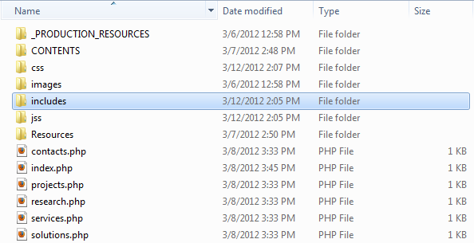

The files that we first want to change are located in the includes folder. Open the includes folder.

1. Once the includes folder is opened you file directory should look like this:

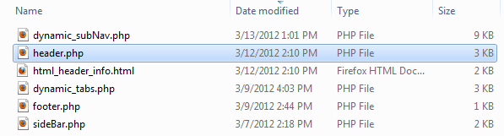

From here you are going to want to open the file labeled header.php using a text editor such as Notepad, Notepad++, or PSPad.

1. Once the header.php document is open it should look something like this:

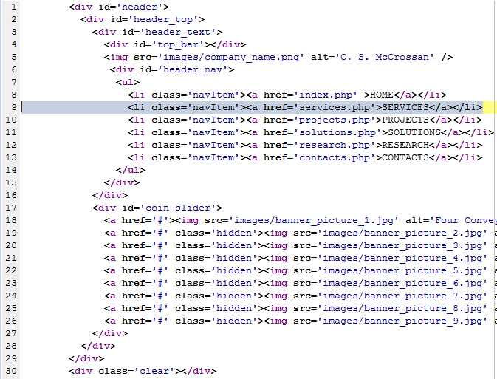

In our example, all of the information that we need to change is located in line 9 of this document. We will replace ‘SERVICES’ with ‘HUMAN RESOURCES’ and replace the services.php in href=’services.php’ with human_resources.php. Please note that in file names the underscore character (shift + -) should be used in place of spaces. This is what the new line 9 should look like:



Save the changes made and close header.php. We will not use it anymore. Refresh the Intranet site and the navigation bar in the header should now look like this:



1. Return to the root directory of the Intranet. You are now going to change the name of the file services.php to the exact thing you replaced it with in the previous step. In this case it would be human_resources.php. This is what your directory should look like now:

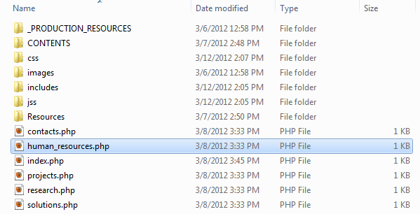

1. We are now going to change things so the correct tab titles are shown for the sub-navigation on the Human Resources page. To do this we need to go into the includes folder again. This time we need to open the file labeled dynamic_tabs.php. Once you open the file you should see something like this near the top of the file (note that your line numbers might be different than the ones here):

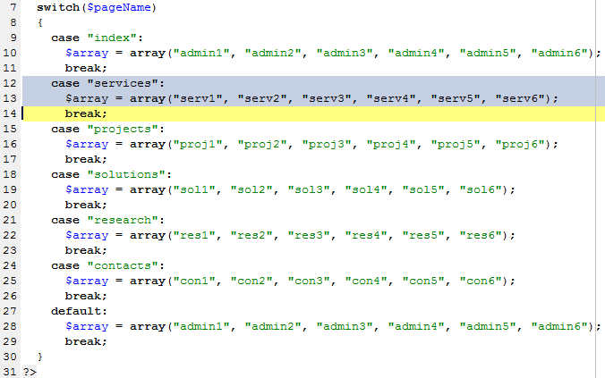

What is happening here is that the page, using PHP, is getting the page name and putting it into the variable $pageName. The page name is the same as the name of the file that the page is loading from. The page name of services.php would be services. The switch function checks $pageName against 6 strings and sets the $array variable based off whether or not $pageName is the same as one of the 6 strings. The values in the $array variable become the titles of the tabs on each departments page.

Highlighted in the above image are the lines that we are going to need to change. We need to change “services” to the same thing that you replaced it with in the previous steps. In this case that is “human_resources”. We also need to replace ‘serv’ in $array with something. What we change it to is what the title of the tabs will be. In this case I am going to replace ‘serv’ with ‘hr’. After these changes the lines will have changed from this:



To this:



Right now the setup is for the maximum of 6 tabs for the Human Resources intranet page. If you wish to have fewer tabs all you need to do is delete an element from the array. Starting with “hr6”, delete everything between the last comma and the closing parentheses, including the last comma, to remove a tab from the navigation. In this case line 15 would not change, only line 16. This is what line 16 would look like if you only wanted there to be 4 tabs on the Human Resources page of the Intranet:



Refreshing the website and clicking on the Human Resources link shows the changes we made worked. Save the changes that you made to dynamic_tabs.php and close the document.

This is what the tabs for my new Human Resources page looks like with all 6 tabs visible (the larger tab being the active tab):



1. The next step is to change the text that gets displayed for the sub-navigation menu in the left corner of the body of the website. To do this we will need to open the file titled dynamic_subNav.php which can be found in the includes folder. Take a few moments to look over the document. At the top of it you should see something like this:

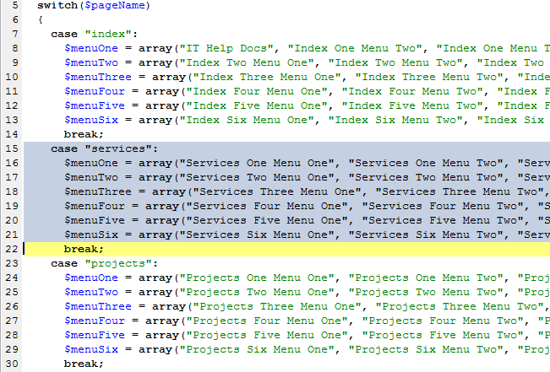

This is where all the titles for the navigation menu in the left corner of the main part of the webpage are stored. I have highlighted what we will be changing for this example. As like before, this code functions by checking the name of the page (using the $pageName variable) against 6 pre-defined strings and then changes the arrays $menuOne, $menuTwo, $menuThree, $menuFour, $menuFive, and $menuSix to have the appropriate information in them. The first thing that we are going to do here is change ‘services’ in line 15 to ‘human_resources’ (exactly like we’ve done the last few steps).

Here is where you can change how many links there are in the navigation in the left corner of the main page for each tab and what each of these navigation items say. $menuOne holds the link titles for the first tab, $menuTwo holds the link titles for the second tab and so on. To change what a link says, delete what is between the double quotations (“”) and replace it with what is desired. Please note that whatever you type for the link text must also be valid as a file name. This means you cannot the following characters: \ / : * ? < > |. I have filled in the first two links for each tab to give you an idea of how this works:

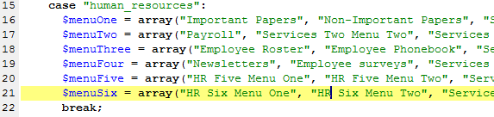

After you have renamed all of the sub-navigation for each of the tabs, save dynamic_subNav.php but do not close it. We will need the information from this document for the next step.

Refreshing the website and going to the Human Resources page and changing the tabs will show that the sub-navigation for each tab has changed to the new text. This is what the changes I have made look like for the first tab ($menuOne holds the strings that make up the link text):

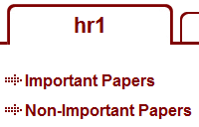

1. THE NEXT COUPLE STEPS ARE IMPORTANT. PLEASE PAY CLOSE ATTENTION TO THE DIRECTIONS. In this step we will now rename a number of files in our directory system to ensure that the code works the way it is supposed to. The first thing you should do is back out of the includes directory to the main directory. Then open the CONTENTS directory and then the CONTENTPAGES directory. You should see 6 folders. Each folder corresponds to a different section of the website. One of these folders will need to be renamed. The folder that gets renamed will be named the same as all the other names that you’ve been changing thus far. In this example I have been replacing ‘services’ with ‘human_resources’ so I would rename the folder here titled ‘services’ to ‘human_resources’

File names before change:

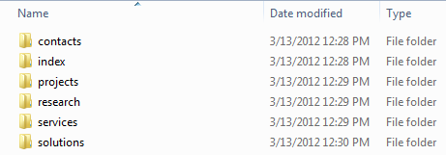

File names after change:

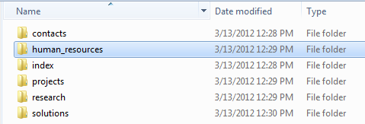

Now open the newly renamed folder and change EVERY appearance of the name that you replaced to the new name. Do NOT go into any folders and change anything yet. We will do that in the next step. For our example, since I changed ‘services’ to ‘human_resources’ I need to change EVERY appearance of ‘services’ to ‘human_resources’ in the newly renamed ‘human_resources’ folder.

Before: After:

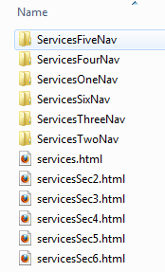 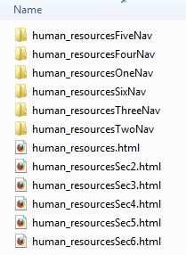

There will be up to 6 html documents in this folder. These contain the main content for each of the tabs for each department. The file names for these HAVE TO remain as they appear above, with the department name followed by some additional text. Changing the name of these files to anything else will cause errors on the website when the user tries to access content. If you are providing content pages for a specific tab you MUST KEEP THE SAME NAME. Copy the name of the old file, delete it, and give the new file THE EXACT SAME NAME or else it will not function properly.

The file human_resources.html provides the content for the 1st tab from the left on the Human Resources page (hr1), human_resourcesSec2.html provides the content for the 2nd tab from the left on the Human Resources page (hr2), and so on until human_resourcesSec6.html which provides the content for the 6th and final tab from the left (hr6).

1. Now it is time to add the content that is linked to by the sub-navigation links that change as tabs change. For the example we have been going through, all the content that is linked to from the navigation on the first tab of the Human Resources page will be in the human_resourcesOneNav folder, all the content that is linked to from navigation on the second tab of the Human Resources page will be in the human_resourcesTwoNav, and so on until human_resourcesSixNav.

The names of these folders cannot change beyond the changes that have been made up to this point. The text after the department name is important in building the website. Changing the text following the department name will result in errors when certain parts of the website are accessed.

There is a specific naming convention that must be followed when adding content pages to any of these folders. The html document for any link in any tab sub-navigation menu must be exactly the same as the text linking to that document. The only difference is that the file name will have no spaces in it.

Here is an example showing this:

These are the text for the first two links on the first tab of the Human Resources Page. Since they are in the first tab, the content files relating to them will go in human_resourcesOneNav

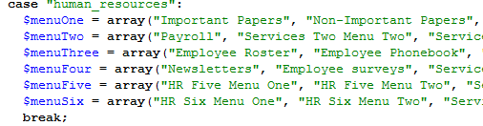

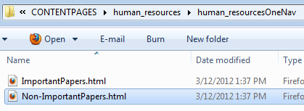

Note the only different between the text for the link and the file name is that the file name has no spaces. This is how it should be for EVERY html page that is linked to by a link from the sub-navigation on each tab.

Once you have finished naming the html documents properly and placing them in the proper folders you will be done updating the website. Save all your changes and refresh the website using CTRL + F5. Check to make sure all the changes that you made are working. If a section of the website is not functioning as intended, trace back up to the step describing it and make sure there were no typos.

**Section Two: Adding a new department**

This is what the navigation in the header of the company Intranet looks like:



Each of the links in this section takes you to the main page for the corresponding department. The steps listed below explain how to add another department to the Intranet. As an example, I will be adding a department called “Admin” to the Intranet.

1. Locate the root directory where all the files for the Intranet are located. Your directory should look something like this:

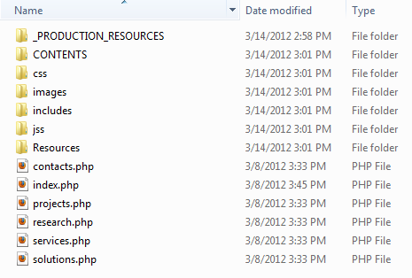

The first thing that you are going to want to do is to copy and paste any one of the PHP files that are in the root directory. You will need to do this once for each department page that you wish to add. Remember the name for the new files exactly as you typed it in because you will be using this name often. In this example, I have copied one additional PHP file and named it ‘admin.php’.

Here is what my root directory now looks like with the new file added:

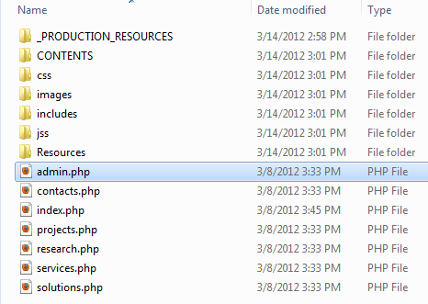

1. Next, open the includes folder. It should look something like this:

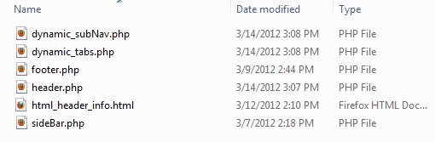

You are going to want to open three of these files in a text editor such as Notepad, Notepad++, or PSPad. In the examples I am using PSPad. The files you need to open are dynamic_subNav.php, dynamic_tabs.php, and header.php.

1. The first of the three files that we are going to work with is header.php. Your header.php should look something like this:

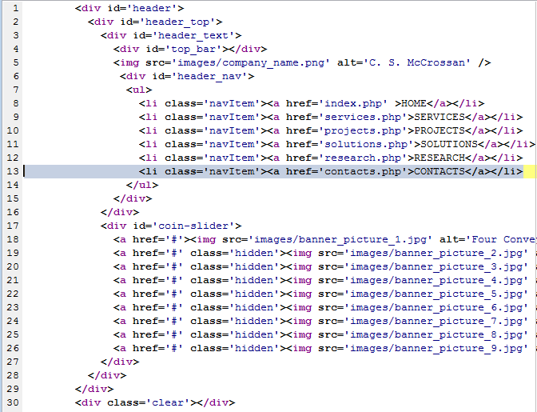

This is the code behind the navigation at the top of the Intranet. Each link takes the user to a different department’s main page. To add a new department you need to copy and paste one of the lines of code similar to the line of code I have highlighted in the example above. The order of lines 8 through 13 in the example DOES matter. Line 8 holds the information for the first link, line 9 holds the information for the second link, and so on until line 13 which holds the information for the last link in the header. For the example I will be adding a link for the Admin Intranet section at the end of the header navigation. If you wish to add a new link between two pre-existing links all you need to do is create a blank line between the two pre-existing links and copy the code into the blank line.

All links information MUST be between the <ul> and </ul> tags or else it will not appear as desired on the webpage. After you have your new line of code pasted in the spot that you wish you need to change where the link is referenced to (the information in the quotes of href=”…”) and the text displayed for the link (the letters that are in all caps). The information between the quotes needs to be replaced with the EXACT name of the file that you added to the root directory in step 1, complete with .php file extension. The text displayed for the link can be anything you wish, just make sure that all of the letters are capitalized.

For my example the changes will look like this:

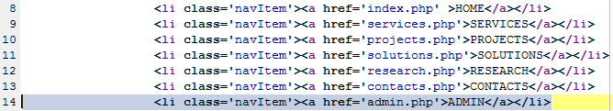

Note that I have a new line (line 14) that was not in the example earlier in this step. That is my new link. The header on the website now looks like this:



1. This step is only necessary if you need to make changes to the way that the navigation in the header is displayed. If you do not need to make any changes to the way that the header navigation is displayed you may skip this step and move onto step 5.

First, return to the root directory and then open the folder called css and then open the file called style.css in the css folder. This is the file that controls a large portion of the visual aspect of the Intranet. ONLY CHANGE WHAT IS SUGGESTED IN THIS STEP. Changing anything else could have a detrimental effect on the visual layout of the Intranet. Once you have styles.css open, find the following phrase: .navItem a (yes the period is required, to search the document hit CTRL+F and then put the required phrase in the appropriate spot). This will take you directly to the place where changes need to be made.

1. If you wish to decrease the space between the text for each link in the navigation find the highlighted line:

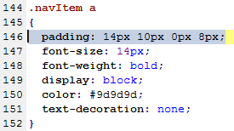

The two values that you can change to alter the distance between the text for each link in the navigation bar are the second and fourth value. Making the values smaller will decrease the distance, making the values larger will increase the distance. Once you change the values, you MUST make sure that they are immediately followed by px as in the example above.

You may play with these values a little bit until you find the spacing that is desired. I suggest trying to find values that keep the link evenly spaced out in the space between the company name on the left and the grey border on the right.

1. This step should only be done if you were unable to get everything to fit using step A. To change the size of the text, you will be changing values in the highlighted line:

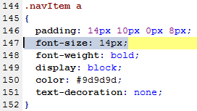

The value here controls the size of the font, the smaller the value, the smaller the size of the font. DO NOT GO SMALLER THAT 12px, any value smaller than 12px will create font that is too small for some people to read comfortably and that is not what we want. This is a last resort and should not be used unless absolutely necessary.

Once the all the links are centered in the white space at the top of the Intranet you are ready to move onto the next step.

1. You may now save the changes made and close header.php and styles.css. The next document that we are going to look at is dynamic_tabs.php. Your file should have a section that looks something like this:

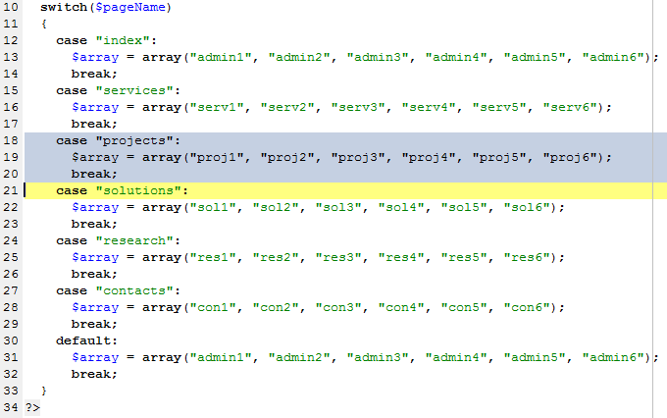

The information contained in this section is used to generate the names of the tabs that are on each department’s Intranet pages. For this step, we will make a copy of the highlighted block of code (lines 18 through 20 in my example) and past it between the last case and the default like this:

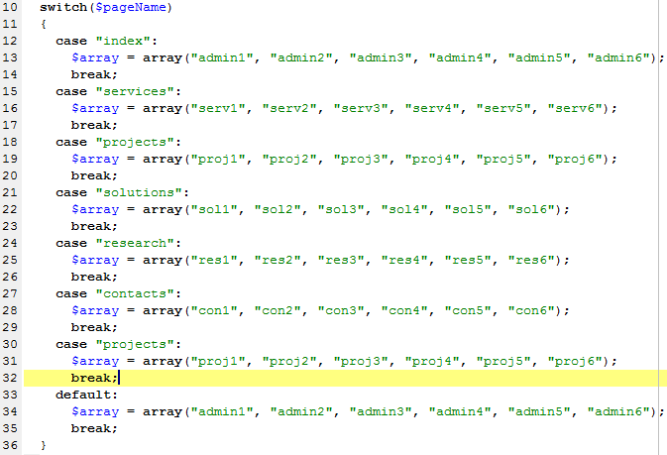

The next part of this step is to change the string that the case checks against in the new block of code that was just copied. The string that we want to replace the old string with needs to be EXACTLY the same as the file name you used in Step 1 but without the file extension (no .php at the end). The elements in $array, as mentioned earlier, represent the titles for the tabs on the new department page. These will need to be changed also to something that makes sense for each tab. Also note that the elements in $array appear in order, the first element appearing in quotes is the title of the first tab for the department page, the second element appearing in quotes is the title of the second tab, and so on.

If you require less than 6 tabs for the department page all you need to do is delete everything between the last comma in $array and the closing parentheses (including the comma).

For the example I am going to replace “projects” with “admin” (the name of the file in the example from step 1 was admin.php) and replace all iterations of proj with admin. The finished code will look like this:

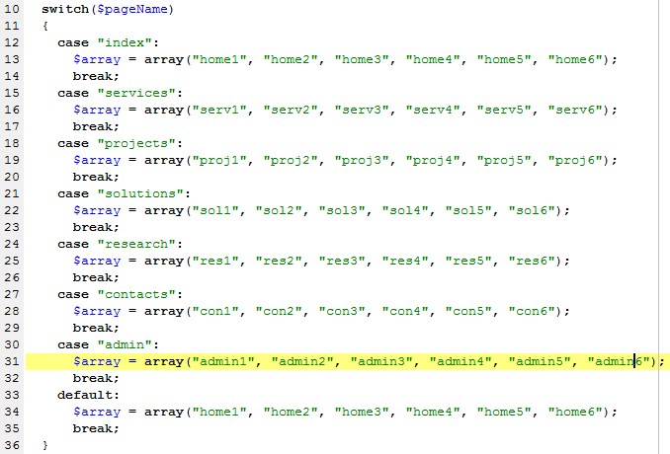

You may also notice that I changed some tab title to “home” from the previous version of “admin”. This was done to prevent any confusion that may have risen due to duplicate names. This set up will display 6 tabs on the new admin page. If I wanted to change that so there were only 4 tabs on the new admin page the line highlighted above would look like this instead:



This is what the tabs for the example look like with the new titles if I choose to have 6 tabs on the admin department page:



Once you are satisfied with the changes made, you may save the dynamic_tabs.php document and close it.

1. Now return to the root directory. From here open the CONTENTS directory and then the CONTENTPAGES directory. Inside the CONTENTPAGES directory should be a number of folders with no other documents. This is what the contents of my CONTENTPAGES directory looks like:

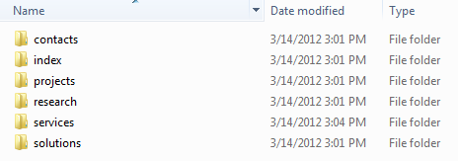

Now you need to copy and paste any of the folders you see into the same directory. Do this once for each new department. You will then give the copied folder the same name that you gave the new file in step 1, sans the file extension (in this case .php). This is what the example looks like after this is finished:

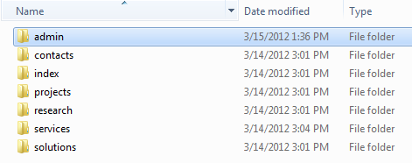

Notice that the highlighted folder above is the new folder and shares the same name as a number of entities that have been renamed throughout the examples.

1. The next thing to do is to open the newly renamed directory. All of the folders and files inside the new directory need to have their name changed. For every iteration of the renaming process all that needs to be done is to replace the existing department name in the name of each entity in the folder with the name that you gave the folder. For the example I will be changing “Solutions” to “admin”. This means that every appearance of the string “Solutions” will be changed to “admin”. DO NOT CHANGE ANYTHING ELSE IN THE NAME OF THESE FILES AND FOLDERS. The suffix after the department name in all of these files is vital to the website being generated in the proper way. Below is a before and after shot of this step being applied to the example that we have been going through:

Before: After:

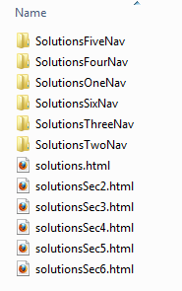 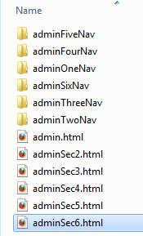

There will be up to 6 html documents in this folder. These contain the main content for each of the tabs for each department. The file names for these HAVE TO remain as they appear above, with the department name followed by some additional text. Changing the name of these files to anything else will cause errors on the website when the user tries to access content. If you are providing content pages for a specific tab you MUST KEEP THE SAME NAME. Copy the name of the old file, delete it, and give the new file THE EXACT SAME NAME or else it will not function properly.

In the example, the file admin.html provides the content for the first tab on the admin department page, adminSec2.html provides the content for the second tab on the admin department page and so on until adminSec6.html, which provides the content for the last tab on the admin department page.

Do not close this folder yet. There are still some things that need to be changed in it.

1. The next step is going to be changing the text that is displayed in the sub-navigation on the left side of the main section of the webpage. This information will change as the user navigates from tab to tab. The links provided in this area provides quick navigation for the user to pages that are linked to from the content provided in the tab body.

To change the text, navigate to the dynamic_subNav.php document. You should see a section of this document that looks like this:

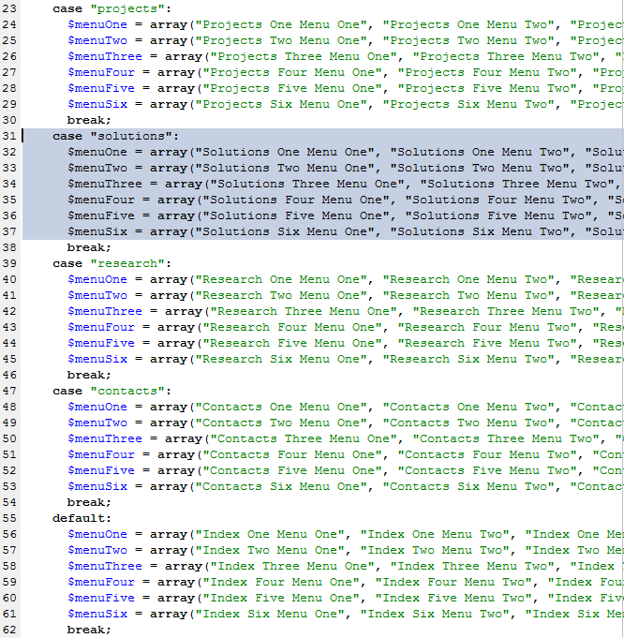

The first thing that is going to need to get done is to add a new block of code between the break; of the last case and default (in the example above the new block of code will go between lines 54 and 55). The block of code that needs to be copied is highlighted above. You do not need to copy this exact block, just all the information starting with case “…” and going to the first break; that you come to. After you copy the code in the right place you need to change the string of characters immediately after the case. The string of characters that you are replacing the old text with is going to be exactly the same as the name of the file that you made in step 1 (sans file extension) In the example I will be changing the string solutions to admin. The new code in the example looks like this now:

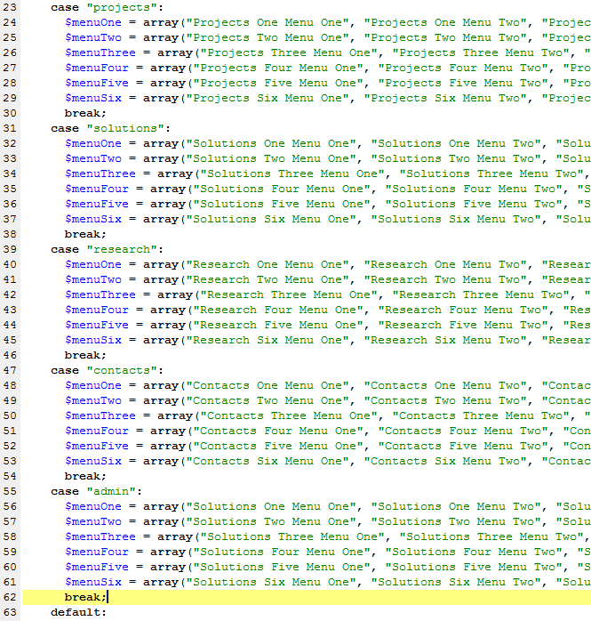

This is where all the titles for the navigation menu in the left corner of the main part of the webpage are stored. I have highlighted what we will be changing for this example. As like before, this code functions by checking the name of the page (using the $pageName variable) against 6 pre-defined strings and then changes the arrays $menuOne, $menuTwo, $menuThree, $menuFour, $menuFive, and $menuSix to have the appropriate information in them.

This is also the spot where you can change how many links there are in the navigation in the left corner of the main page for each tab and what each of these navigation items say. $menuOne holds the link titles for the first tab, $menuTwo holds the link titles for the second tab and so on. To change what a link says, delete what is between the double quotations (“”) and replace it with what is desired. Please note that whatever you type for the link text must also be valid as a file name. This means you cannot the following characters: \ / : * ? < > |. I have filled in the first two links for each tab in the new section of code to give you an idea of how this works:

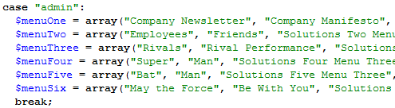

Saving the changes that you made to dynamic_subNav.php and refreshing the website now reflects the changes that we have made to the text for each of the items in the navigation menu. Here is a screenshot of a section of the tab sub-navigation from the website using the example:

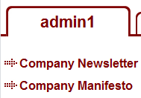

1. Now go back to your file directory. Before going to the next step, we will take a few moments explain how the content for the sub-navigation in each tab is handled.

For the example that we have been going through, all the content associated with the links on the first tab of the admin department page will be in the folder adminOneNav, all the content associated with the links on the second tab of the admin department page will be in the folder adminTwoNav, and so on.

The names of these folders cannot change in any way other than way previous described. Changing the text after the department name will cause the website to not function as intended. This means content will not be displayed when users click on links. Please ONLY change the department name portion of these files and folders.

There is a specific naming convention that must be followed when adding content pages to any of these folders. The html document for any link in any tab sub-navigation menu must be exactly the same as the text linking to that document. The only difference is that the file name will have no spaces in it. Therefore, all you need to do to add content for a link in the sub-navigation on the main page for a tab is to place the appropriately named file in the appropriate file.

Here is an example showing this:

These are the titles for the top two links on the first tab of the admin department page. Since they are in the first tab, the content associated with these two links will be placed in the adminOneNav folder.

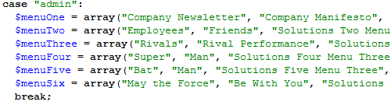

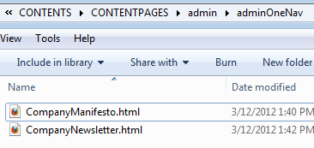

Here are the two files that contain the content for the first two links on the first tab on the admin department page. Notice that the only difference between the names of the file here and the text associated with the links is that the name of the file has no spaces. This is how it should be for EVERY html page that is linked to by a link from the sub-navigation on each tab.

Once you have properly named all the content files that you wish to add for the sub-navigation, save all your changes and refresh the website using CTRL + F5. Check to make sure all the links are functioning properly and that they are all going to the right place. If there are any errors at this point, go back to the appropriate step and walk through it again to make sure there were no errors in where files were placed or what files/folders were named.